Use this guide to confer students with two degrees in Workday Student.
There are two steps to process conferral for students with two degrees (BA and BS).
Step 1: Confer all other eligible students
Step 2: Confer students with two degrees
STEP ONE: CONFER ALL ELIGIBLE STUDENTS
- Open the Maintain Program Credential Policy by searching in the search bar and selecting the task.
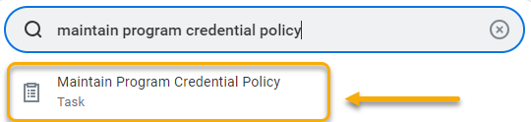
- Select the Academic Unit / Academic Level button.
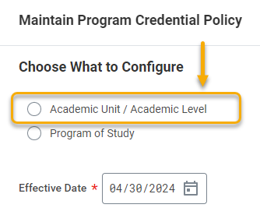
- Academic Unit and Academic Level fields will appear. In the Academic Unit field, select “Western Colorado University”. In the Academic Level field, select “Undergraduate”. 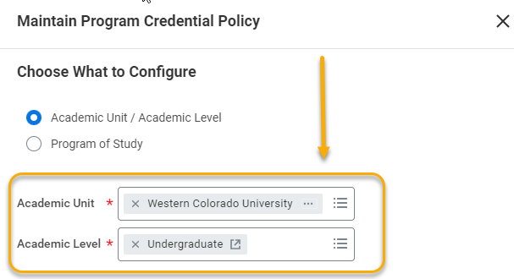

- In the Effective Date field, enter “01/01/1900”. Click “OK”.

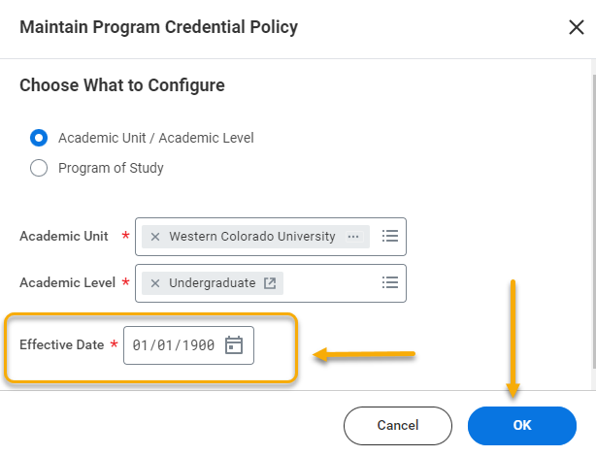
- On the next screen, select the All programs button.
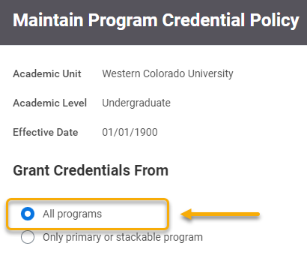
- The Grant Multiple Credentials of Same Type checkbox will appear. Leave this box unchecked. Click “OK”.
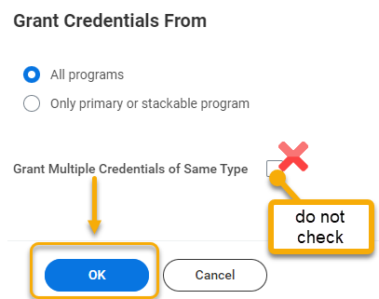

STEP 2: CONFER STUDENTS WITH TWO DEGREES
- Now, you can individually confer students with two degrees or use the Manage Program Completion task.

Once degrees are conferred, navigate back to the Maintain Program Credential Policy.

- Re-enter the same information, including the effective date of 01/01/1900. Click “OK”.


